**Data Wrangling – OpenStreetMap**

In this project, I used python to audit and clean the OpenStreetMap dataset and import it into MongoDB for further analysis.

**Area**

I live and work in the San Jose now, so I just went to https://mapzen.com/data/metro-extracts/metro/san-jose_california/ and downloaded OSM XML file.

**Sample Dataset**

Since the original file is 350 MB, I extract a sample dataset around 11 MB.

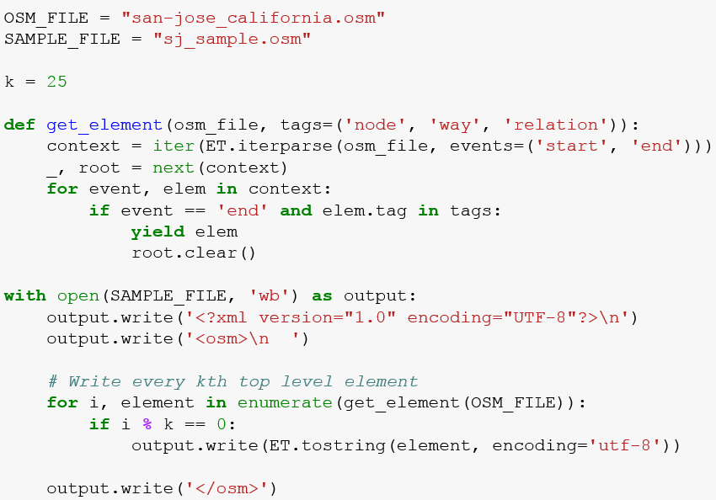

**Audit & Clean Dataset**

First, I showed how many tags in this dataset. we could see a large amount of things to be audited. In this project, I will further explore 'addr:street' and 'addr:postcode'.

**Addr:street**

During the audit, we could see the inconsistency of the street name, such as “Rd” and “Road”, “Ct” and “Court” and so on and so forth.

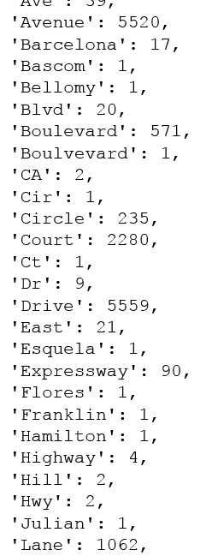

I only selected the expected street name and do mapping for them.

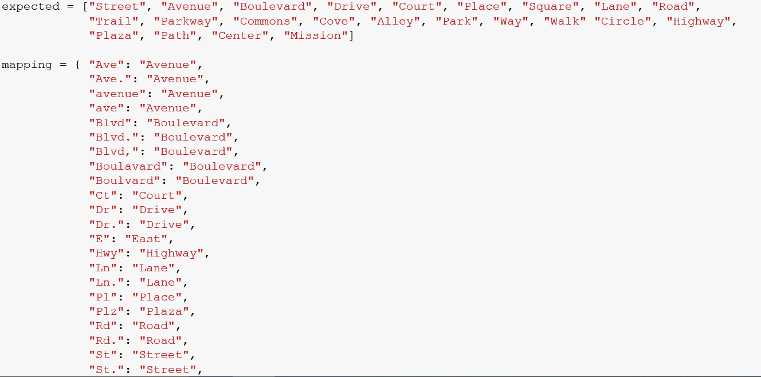

Addr:postcode

During the audit, I found the postcode are also inconsistent. Sometimes, it has “CA” or “CU” inside. Sometimes they are 5 digits instead of 9 digits.

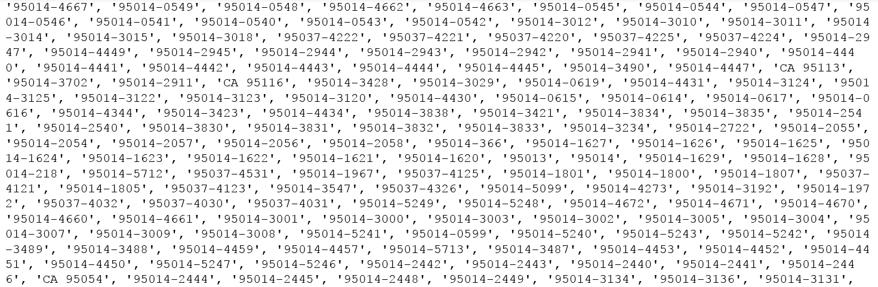

I removed CA, change all the zipcode to five digits and removed "CU" as well.

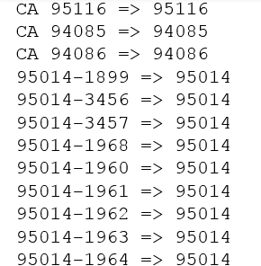

**Parse Data to JSON**

After auditing and cleaning the data, I parse the data to JSON file.

**Import Dataset to MongoDB**

In command, mongoimport --db OpenStreetMap --collection SanJose --file san-jose_california.osm.json.

**Explore Dataset**

Number of unique users

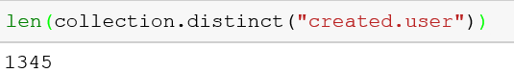

Number of nodes and ways

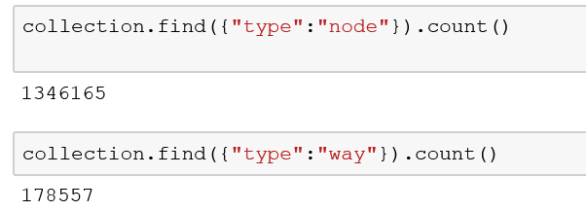

Number of total documents

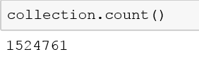

Top 5 contribution users

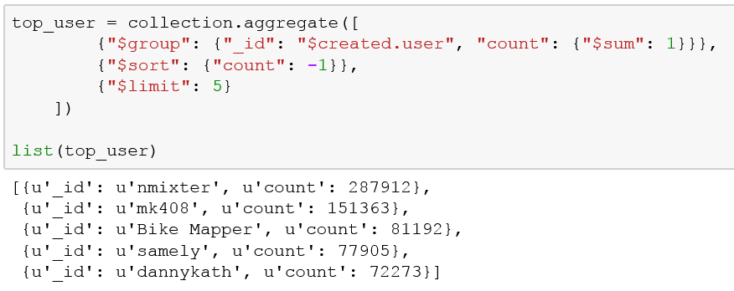

Top 5 Amenity

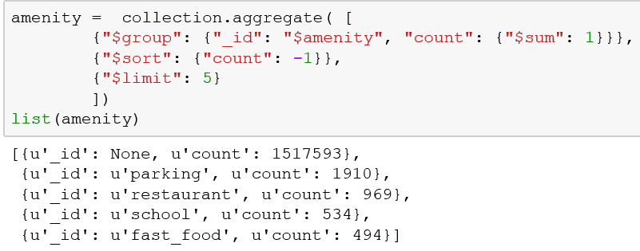

Amenity in each postcode

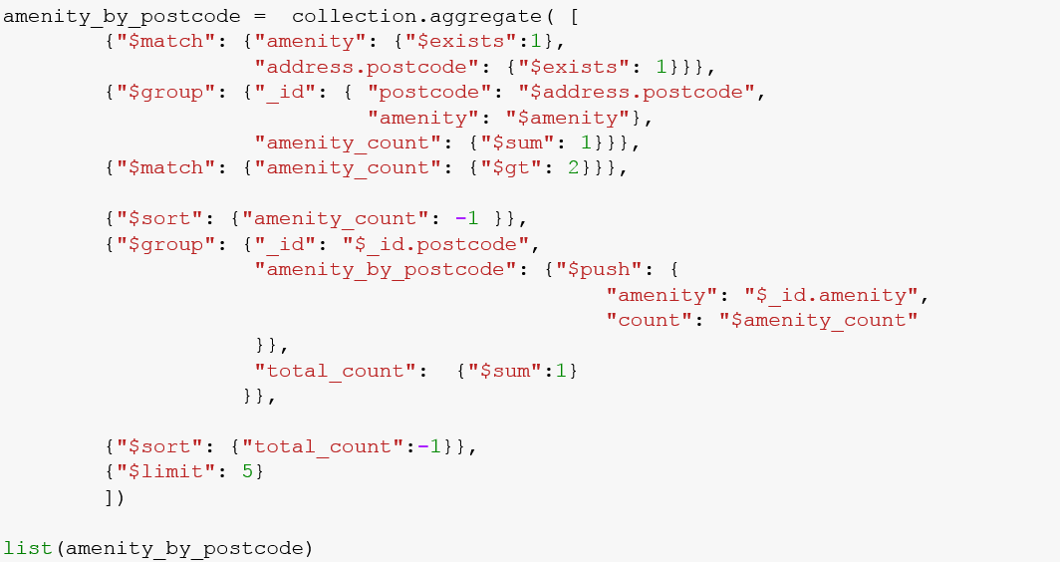

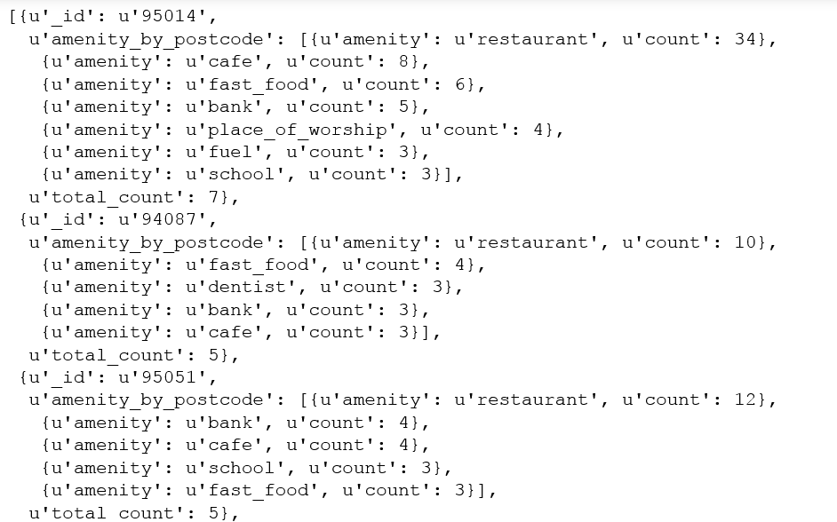

Looks like 95014 area is the most common area with different kings of stores, banks, and schools. From Google search, 95014 is Cupertino area, where I usually go for lunch and dinner :)

**Other ideas about the dataset**

When I went through the database, there are a lot of information missing. For example, when I query the amenity, there are 1517593 none value

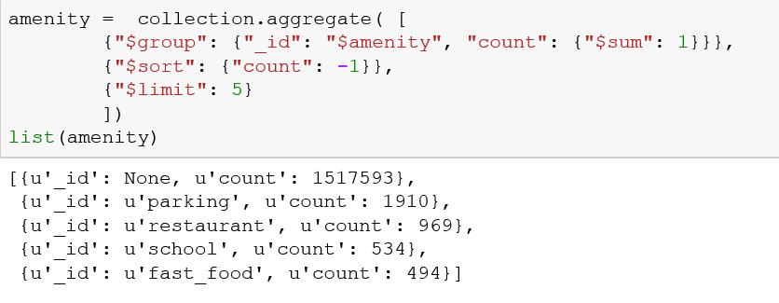

In my opinion, it is probably because there are large amounts of data sources. Since each data source has different data structure, so sometimes, it may miss the "amenity" part. Also, we can see that most of the data sources are unknown!

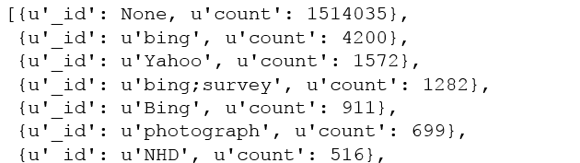

**I recommend to use one stable data source like Google Map API to get data and remain the same data structure. In that way, we can easily audit, clean and maintain the dataset.**

**Conclusion**

During this project, I audited, cleaned and explored San Jose OpenStreetMap data. I found two problems. One is the addr:street - street name is inconsistent such as "Rd" and "Road". I created a mapping for those street names and delete unexpected street names. The other problems is the postcode. I identified unexpected "CA" and "CU", and updated all 9 digits to 5 digits, which I think is a good for further analysis.

When I implemented this data improvement, I found:

Benefits:

1. We have cleaner data to do analysis – for example, use postcode to count something.

2. Now we know some tags have the problems, then we can do something during the data collection phase to prevent them.

Anticipated Problems:

1. Everyone has different approach to clean the data, it’s hard to combine each person’s dataset
2. We might lose some information when we clean the data

When I looking at tag at the very beginning of the project, I found that there are hundreds of tags there. So one of my suggestions is to reduce the amount of tags and created more general tag names. In that case, we can save time to audit and clean the dataset.

I also plan to audit and clean more tags in the near future to get more familiar with OpenStreetMap dataset.